ÔN TẬP TỪ 23 đến 27/03/2020

1/ Read and draw the times
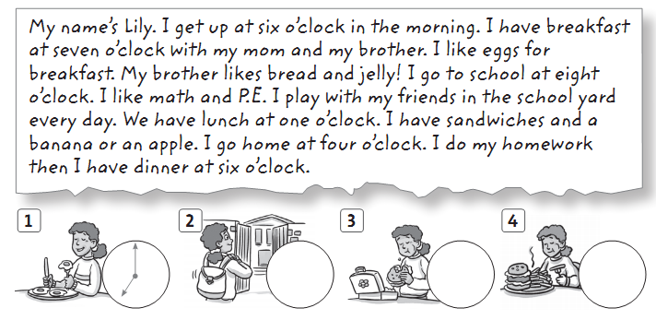
2/ Read again and write T (true) or F (false)
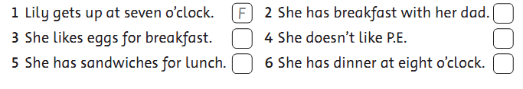

3/ Look and complete the sentences.
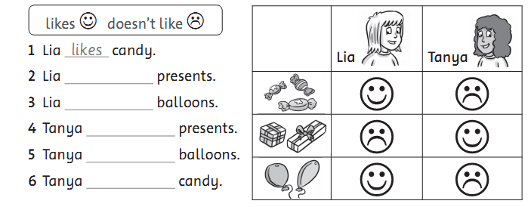
4/ Look and answer.
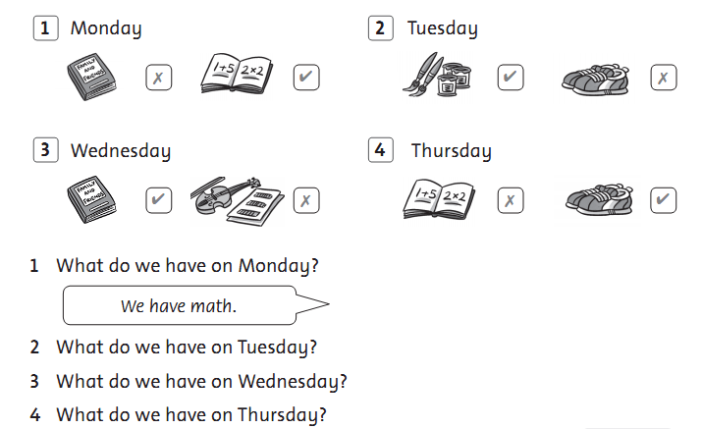

5/ Look and read. Put a tick () or a cross () in the box. There are two Examples.
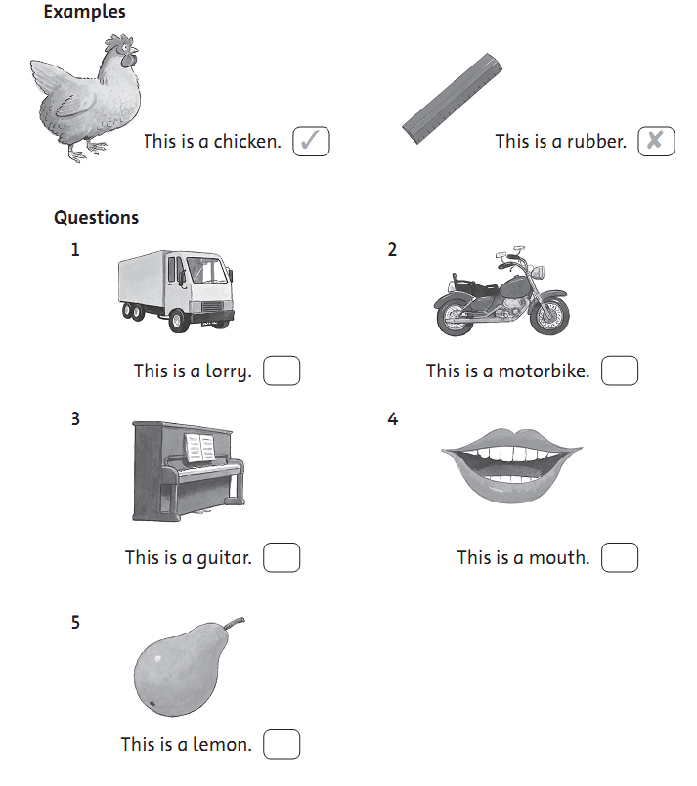

6/ Look and read. Write Yes or no. There are two examples.
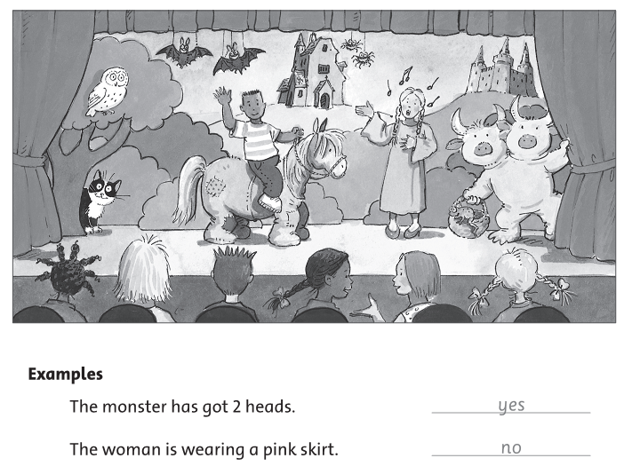
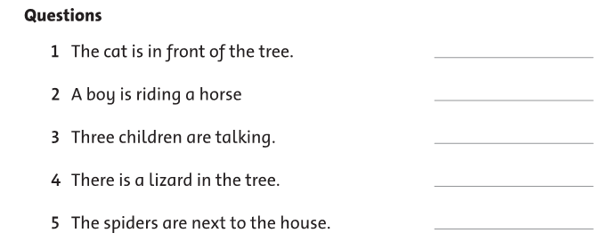

7/ Look at the pictues. Look at the letters. Write the words. There is one example.
