REVIEW – GRADE 5

Question 1: Look and read. Put a tick (√) or cross(X) in the box:
3
- He likes ice cream. ²
√
1
- She is in the computer room.
- We eat bread, eggs, meat and tomato. ₄
- It’s sunny.
5
- Their bags are big.

Question 2: Look at the picture and the letters. Write the words.

1.  lmpu p l u m
2.  hsore _ _ _ _ _
3. 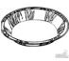 ptale _ _ _ _ _
4. 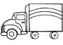 kurtc _ _ _ _ _

  - sbhru _ _ _ _ _
6.  kace _ _ _ _

Question 3: Look and read. Write Yes or No on the dots.

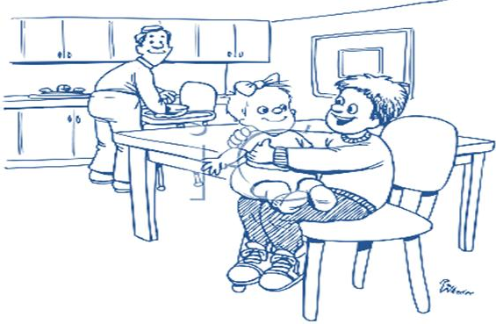

    - This is a bedroom. ..No..
    - There are three people in the kitchen. ...........
    - Tom’sA Dad is cooking dinner. ...........
    - Tom is playing with his brother ...........
    - His sister has long hair. ...........

Question 4: Fill in each gap with a suitatble form of the word.
Hi! My name is Lucy. I (get up) at half past six. I_______(have) breakfast with my parents and my younger sister, Paula. I (like) cereals but my sister (like) bacon and eggs. My Mum and Dad (have) coffee and toast. We go to school by bus, but my father (go) by train. My mother (work) at home, she (be) a housewife.
My sister and I have lunch at school, because in the afternoons we
(do) activities: I (sing) in the choir and
(play) basketball, my sister (go) to art room and
(play) the piano.
After school we (go) home and my mother
(help) us do our homework. We also help Mum. My sister and
I go to bed at nine o'clock. On Sundays we (visit) our
grandmother, I (like) her very much! She (make) us cakes and we play all afternoon with our cousins. It (be) fun!

Question 5: Read the passage from question 4 and choose the correct answer.
- On weekdays, Lucy gets up at...
  - seven o'clock. B. eight o'clock. C. half past seven.
- She likes ...
  - bacon and eggs. B. cereals. C. coffee and toast.
- She has lunch...
  - at school. B. at home. C. at a restaurant.
- In the afternoons, Lucy...
  - has lessons. B. plays football and reads.
C. plays basketball and sings in the choir.
- Her sister...
  - has music lessons.
  - plays tennis.
  - plays badminton.

- Lucy and her sister do the homework...
  - alone.
  - with their father.
  - with their mother.
- In the evenings they...
  - watch TV. B. go out. C. listen to music.
- In the weekends, Lucy and her family...
- go out for dinner.
- visit friends.
- visit the grandmother.
- Grandmother likes to...
  - play with them. B. make them cakes. C. watch TV.

Question 5: Read the passage from question 4 and answer the questions.
- How do they go to school?

- Does Lucy get up at seven thirty?

- What does their mother do?
_
- Where do Lucy and her sister have lunch?

- Does her sister play the guitar?

- What time do Lucy and her sister go to bed?

- Who do they play all afternoon with?

